3 Ingredient M&M Slice
These M&M slice are as tasty as they are simple and the kids will love getting involved. Watch out for the sugar though – this one is a sometimes snack!
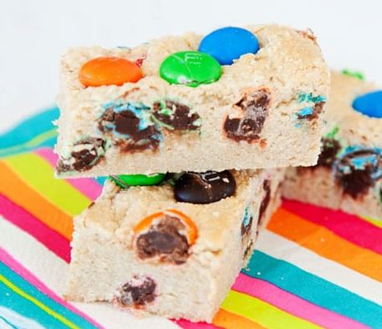
What you need
- Slice Tray
- Baking Paper
- 220g packet Plain Biscuits
- 1 cup M&Ms
- 400g can Condensed Milk
Directions
- Line the slice tray with baking paper.
- Process the biscuits in a blender or food processor to fine crumbs and the pour into a large bowl.
- Add the condensed milk and M&Ms and combine well.
- Press the mixture into the prepared tray and put in the fridge to set.
- When set, cut into approximately 16 squares. Best to store in fridge.
Alternative
You can also bake this recipe. Preheat an oven to 160°C and bake mixture for 20 minutes. Let it cool in the tray before cutting into slices.

