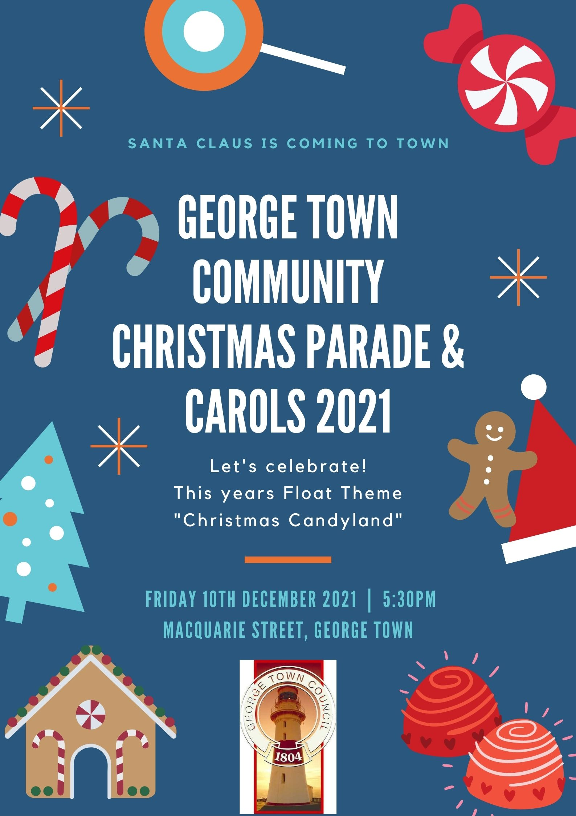

CHRISTMAS PARADE FLOAT APPLICATION

INFORMATION
- Please read all information carefully as you are required to acknowledge and understanding the conditions of entry.
- The theme for the 2021 Christmas Parade is “Christmas Candyland”. The Carols will follow after the Parade in the Graham Fairless Centre.
- The 2021 Christmas parade will be marshalled at the George Town Fire Station in Goulburn Street from 4.45pm.
- The parade will start at 5.30pm commencing from the Fire Station; then turn right into Macquarie Street, continue to Windmill Point turn and then return back up Macquarie Street returning to the Fire Station or Anne Street and this will be determined by the Marshalls prior to the parade.
- Following the parade, floats will assemble at a designated area still to be determined.
- All floats are to follow the directions of the Marshalls.
- Entries close on Friday 19th November 2021. Please send your entry to Council at PO Box 161, George Town, 7253, email dravidr@georgetown.tas.gov.au; or drop into the Council Office.

GENERAL REQUIREMENTS
- All drivers must adhere to Tasmanian Road Safety Rules and Standards.
- The movement of the Parade will be controlled by the State Emergency Service (SES) and Tasmania Police. Participants must adhere to their directions at all times.
- Bike riding, skateboarding, rollerblading and scooter riding are all permitted in the Parade, however, appropriate personal protective equipment must be worn at all times. Helmets are a requirement of participation. All road and traffic rules are to be followed throughout the parade.
- Anyone walking in the parade must be in front or behind a float; there is to be no walking beside floats
- If people are aboard vehicles, please make sure they receive adequate adult supervision and reasonable restraining measures are in place, ie a rope barrier.
- By entering in the Parade you agree to the George Town Council taking photographs and video footage of your entry, including individual involved. You further acknowledge that Council has the authority to publish and use this material for subsequent advertising and marketing purposes.
- Throwing of any item from a float is prohibited, as it may encourage young people to run out in front of moving vehicles.
- Handing out of items along the Parade route is NOT permitted due to COVID -19 restrictions, this includes lollies.
- Only ONE Santa Claus is permitted to participate in the Christmas Parade. This Santa will be provided by the organisers.
- This year we would ask Carolers to join the parade and sing either on foot or on a float. This year we woud like to combine to two events and will also have Carols in the Graham Fairless Centre following the parade. Parade route has been extended to Windmill Point and returning up Macquaries Street due to social distancing rules.

VEHICLE SAFETY
- All vehicles and trailers used in the parade must be registered and driven by individual s with the appropriate license.
- Vehicles and trailers used in the parade must be insured (minimum third party insurance).
- Do not attach anything to the exhaust, drive/tail shaft or wheels of your vehicle.
- Do not obstruct the steering of the vehicle.
- Do not obscure the driver’s vision, including the windscreen and rear view mirrors.
- Secure all large, loose items to the vehicle appropriately.
- The vehicle should not leak any fluids.
- All vehicles must move no faster than walking pace.
- The movement of the Parade will be controlled by the State Emergency Service (SES) and Tasmania Police. Participants must adhere to their directions at all times.
- Bike riding, skateboarding, rollerblading and scooter riding are all permitted in the Parade, however, appropriate personal protective equipment must be worn at all times. Helmets are a requirement of participation.

ENTRANT AND SPECTATOR SAFETY
- At the conclusion of the Christmas Parade, all entrants are to comply with the conditions of the Traffic Management Plan to be supplied on application.
- All floats will be directed to a specific parking area by one of the two traffic management personnel.
- No person is to leave the float until it has come to a stationery position.
- Be aware at all times of pedestrians who may have left their float.
The parade Marshalls have the authority to remove any entrant who does not comply with parade rules. We ask that you comply with all conditions to avoid your termination from the parade.

PRIZES WILL BE AWARDED FOR
- Best Themed Float
- Best Walking Entry
- Most Entertaining
- Encouragement Award
- Best Lyrical Performance
- Best Emergency Services
Walking Groups to marshall into the Community Hub car park off Elizabeth Street.

Vehicles to marshall into Regent Square. Two traffic management personnel will be on site to direct you to a parking bay.

To further manage traffic, vehicles needing to depart immediately after the parade are to continue down Elizabeth Street and exit the area. (Please signal your intention to the marshal at the Regent Square parking turn-off.
Prize allocation will be at the discretion of the Judges. Entrants are asked to indicate which category (or categories) they feel best suits their entry.
Prizes will be announced at the conclusion of the Parade, and will be announced in the external foyer area in front of the Memorial Hall.

For more information about the Christmas Parade, contact Meagan or Dravid at the Council on 6382 8800, or email dravidr@georgetown.tas.gov.au
Walking Groups to marshall into the Community Hub car park off Elizabeth Street.

Vehicles to marshall into Regent Square. Two traffic management personnel will be on site to direct you to a parking bay.

To further manage traffic, vehicles needing to depart immediately after the parade are to continue down Elizabeth Street and exit the area. (Please signal your intention to the marshal at the Regent Square parking turn-off.

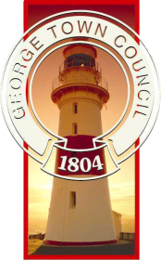
Friday 10th December 2021 commencing at 5.30pm
Theme : Christmas Candyland

REGISTRATION FORM
Name of Organisation / Individual
Contact Person
Address
Contact Details Phone Email
Type of Float
Number of people (approx)
Will your entry have music?
Please provide further details which will enable the Parade MC to describe your organisation, and your float during the parade.
I have read all the information provided in this application, including the requirements, and agree to abide by them.
Signature : Please print name

