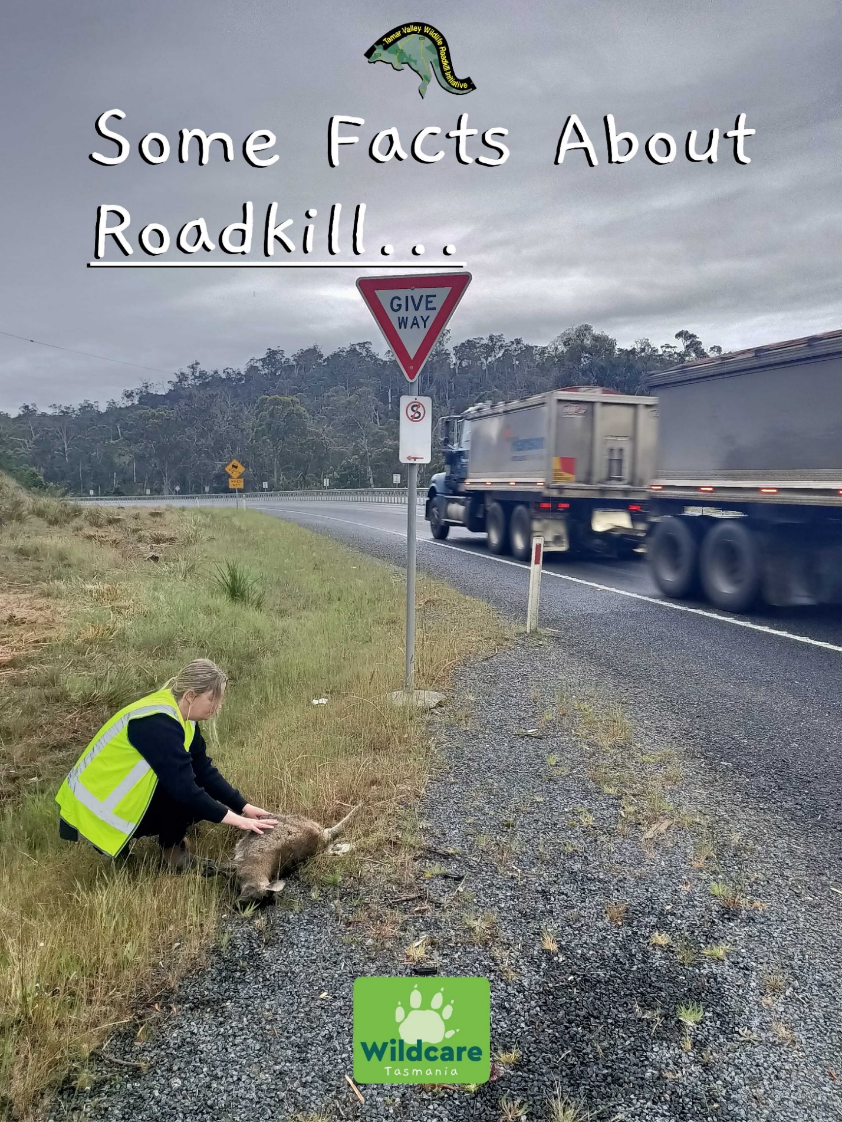

The density of roadkill in Tasmania is higher than elsewhere including the mainland and overseas hence it’s reputation ‘Tasmania the Roadkill Capital of the World’. The average density 0.372 per km was found in a survey taken over 15,000 kilometers, ref Alister Hobday and Melinda Minstrel. The difference between speed and clustering in hotspots suggest that vehicle speed reduction in specific areas may be effective in reducing the numbers killed. Other mitigation measures will vary according to species but whatever measures are used changing driver behaviour is far more effective than changing animal behaviour.
It is interesting to note that the reporting of roadkill occurs at all hours, viz,
Mammal Bird Other Splat(Unidentified)
% % % %
12m – 6am 85.71 8.57 2.86 2.86
6 am – 12n 86.82 6.79 4.76 1.63
12n – 6 pm 76.99 10.03 10.90 2.08
6pm – 12n 70.63 15.00 13.13 1.24
In a survey done over three years 50% could be identified as species with the common Brush Tail Possums and Tasmanian Pademelons the most common species identified both in overall numbers and the frequency of trips encountered. Bennetts Wallabies, and Forrester Kangaroos also enter into the list but one species of real concern is the Tasmanian Devil the population which is already under stress effected by devil facial tumour disease.
The seasonal occurrence such as summer and autumn account for higher numbers of roadkill due to dispersement, young animals venturing away from habitat, and a greater number of vehicles on the road. Speed reduction in specific areas and clustered hotspots may be effective in mitigating the number of animals killed.
Mitigation measures used to change animal behaviour have been attempted in a variety of ways including ultrasonic whistles, underpasses, overpasses, roadside lighting or reflectors, the reduction of roadside grass and water, and escape routes It is estimated that there are over forty, possibly more. Attempting to change animal behaviour has not been a success. Research has shown that ultra sonic whistles attached to vehicles have little or no effect, under passes and overpasses allow predators to follow native wildlife through, virtual fencing has been trialed and still has some issues such as vandalism and destruction of the devices by insect pests, installation has not always been done correctly however it needs further investigation and has potential. Escape routes have to be carefully designed. The vastness of roadside verges puts a huge demand on councils and road managers.
Human measures to mitigate roadkill have been the most effective. Driver education plays an important part. Using the horn to scare off animals, reducing speed in wildlife zones between dusk and dawn – reducing speed by 20 kph in wildlife zones over a 200 km journey will add a mere 3 minutes to the journey and reduce roadkill by 50%, keeping headlights on high at night gives animals a greater warning and will keep the driver alert, watch for features like steep banks that can cut off an animals escape, throwing rubbish like food on the road will entice scavenging animals increasing the risk of roadkill, looking out for road signs and roadkill that indicate wildlife hotspots, and drivers should exercise extra care in winter.
Roadkill also has a direct impact on the human population through accidents and insurance claims. It is understood that Insurer AAMI handled 21,000 animal collision claims across the country between February 2019 and January 2020. In Tasmania accidents as a result of vehicle/animal collisions have been linked to three human fatalities in the period 1993 – 2003 and an average of 7.2 injury causing accidents per year were reported to police over the same period (Magnus 2006). A larger number of single-vehicle accidents may be related to animal interactions – the animals escaped but the humans did not.
The experience of tourists is also negatively affected by encountering high levels of roadkill when they visit Tasmania.
In addressing roadkill one of the key issues appears to be the lack of government funding. We need to work hard to bring the government on side. Roadkill at the present level is impacting negatively on the conservation of our wildlife and the bio-diversity of our state. It is estimated that we are losing our animal population at the rate of between 400,000 and 500,000 annually nearly as many animals a year as the size of our human population.
So we as drivers must be more aware. As an American academic finished a discussion on roadkill recently by saying, quote “the best thing we can do to save our wildlife is stop running over them”.

Bruce George
Tamar Valley Wildlife – Roadkill Initiative
Mob : 0478947217 E. tamarvalleywildliferoadkillini@gmail.com

I would like to acknowledge Alistair J Hobday,and Melinda Minstrell ; School of Zoology University of Tasmania; CSIRO Marine and Atmospheric Research, Department of Rural Health-Faculty of Health Science University of Tasmania, re abstract ‘Distribution and abundance of roadkill on Tasmanian Highways : human management options.’
